Lock
ReetrantLock
公平锁和非公平锁

公平锁
final void lock() { acquire(1); //抢占1把锁.
}
public final void acquire(int arg) { -> AQS里面的方法if (!tryAcquire(arg) &&
acquireQueued(addWaiter(Node.EXCLUSIVE), arg)) selfInterrupt();
}
protected final boolean tryAcquire(int acquires) { final Thread current = Thread.currentThread(); int c = getState();
if (c == 0) { //表示无锁状态
if (!hasQueuedPredecessors() &&
compareAndSetState(0, acquires)) { //CAS（#Lock） -> 原子操作| 实现互斥
的判断
setExclusiveOwnerThread(current); //把获得锁的线程保存到exclusiveOwnerThread中
return true;
}
}
//如果当前获得锁的线程和当前抢占锁的线程是同一个，表示重入else if (current == getExclusiveOwnerThread()) {
int nextc = c + acquires; //增加重入次数. if (nextc < 0)
throw new Error("Maximum lock count exceeded"); setState(nextc); //保存state
return true;
}
return false;
}

非公平锁

final void lock() {
//不管当前AQS队列中是否有排队的情况，先去插队
if (compareAndSetState(0, 1)) //返回false表示抢占锁失败setExclusiveOwnerThread(Thread.currentThread());

else

}

acquire(1);

public final void acquire(int arg) { --AQS if (!tryAcquire(arg) &&
acquireQueued(addWaiter(Node.EXCLUSIVE), arg))

selfInterrupt();
}
protected final boolean tryAcquire(int acquires) { return nonfairTryAcquire(acquires);
}
final boolean nonfairTryAcquire(int acquires) { final Thread current = Thread.currentThread(); int c = getState();
if (c == 0) {
//hasQueuedPredecessors
if (compareAndSetState(0, acquires)) { setExclusiveOwnerThread(current); return true;
}
}
else if (current == getExclusiveOwnerThread()) { int nextc = c + acquires;
if (nextc < 0) // overflow
throw new Error("Maximum lock count exceeded"); setState(nextc);
return true;
}
return false;
}

加入队列并进行自旋等待
public final void acquire(int arg) { if (!tryAcquire(arg) &&
acquireQueued(addWaiter(Node.EXCLUSIVE), arg)) selfInterrupt();
}

acquireQueued(addWaiter(Node.EXCLUSIVE), arg)
addWaiter(Node.EXCLUSIVE) -> 添加一个互斥锁的节点

acquireQueued() -> 自旋锁和阻塞的操作

private Node addWaiter(Node mode) {
//把当前线程封装成一个Node节点。
Node node = new Node(Thread.currentThread(), mode); //后续唤醒线程的时候，需要得到被唤醒的线程.
// Try the fast path of enq; backup to full enq on failure Node pred = tail;
//假设不存在竞争的情况
if (pred != null) { node.prev = pred;
if (compareAndSetTail(pred, node)) { pred.next = node;
return node;
}
}
enq(node); return node;
}
private Node enq(final Node node) {
for (;;) {//自旋Node t = tail;
if (t == null) { // Must initialize
//初始化一个head节点
if (compareAndSetHead(new Node())) tail = head;
} else {
node.prev = t;
if (compareAndSetTail(t, node)) { t.next = node;
return t;
}
}
}
}

//node表示当前来抢占锁的线程，有可能是ThreadB、 ThreadC。。final boolean acquireQueued(final Node node, int arg) {
boolean failed = true; try {
boolean interrupted = false; for (;;) { //自旋

//begin ->尝试去获得锁(如果是非公平锁) final Node p = node.predecessor();
if (p == head && tryAcquire(arg)) { //如果返回true，则不需要等待，直接返
回。
setHead(node);
p.next = null; // help GC failed = false;
return interrupted;
}
//end
//否则，让线程去阻塞(park)
if (shouldParkAfterFailedAcquire(p, node) && parkAndCheckInterrupt()) //LockSupport.park interrupted = true;
}
} finally {
if (failed)
cancelAcquire(node);
}
}

final boolean acquireQueued(final Node node, int arg) { boolean failed = true;
try {
boolean interrupted = false; for (;;) {
final Node p = node.predecessor(); if (p == head && tryAcquire(arg)) {
setHead(node);
p.next = null; // help GC failed = false;
return interrupted;
}
if (shouldParkAfterFailedAcquire(p, node) && parkAndCheckInterrupt())
interrupted = true;
}
} finally {
if (failed)
cancelAcquire(node);
}
}

//ThreadB、 ThreadC、ThreadD、ThreadE -> 都会阻塞在下面这个代码的位置. private final boolean parkAndCheckInterrupt() {
LockSupport.park(this); //被唤醒. (interrupt()->)
return Thread.interrupted(); //中断状态（是否因为中断被唤醒的.）
}

unlock
public final boolean release(int arg) { if (tryRelease(arg)) {
Node h = head; //得到当前AQS队列中的head节点。
if (h != null && h.waitStatus != 0) //head节点不为空unparkSuccessor(h); //
return true;
}
return false;
}
private void unparkSuccessor(Node node) {

int ws = node.waitStatus; if (ws < 0) //表示可以唤醒状态
compareAndSetWaitStatus(node, ws, 0); //恢复成0

Node s = node.next;
if (s == null || s.waitStatus > 0) { //说明ThreadB这个线程可能已经被销毁，或者出现异常...
s = null;
//从tail -> head进行遍历.
for (Node t = tail; t != null && t != node; t = t.prev) if (t.waitStatus <= 0) //查找到小于等于0的节点
s = t;
}
if (s != null)
LockSupport.unpark(s.thread); //封装在Node中的被阻塞的线程。ThreadB、
ThreadC。
}

线程的通信

共享内存
wait/notify -> 基于某个条件来等待或者唤醒
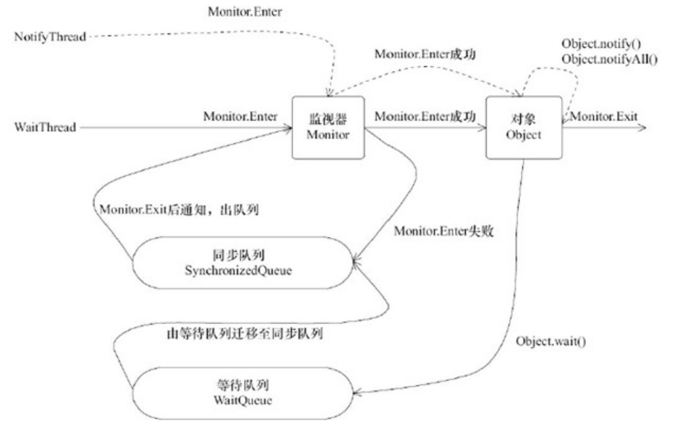

Wait/Notify

public class Consumer implements Runnable{ private Queue<String> bags;
private int maxSize;

public Consumer(Queue<String> bags, int maxSize) { this.bags = bags;
this.maxSize = maxSize;
}

@Override
public void run() { while(true){
synchronized (bags){ if(bags.isEmpty()){
System.out.println("bags为空");
try {
bags.wait();
} catch (InterruptedException e) { e.printStackTrace();
}
}
try {
Thread.sleep(1000);
} catch (InterruptedException e) { e.printStackTrace();

执行。
}
String bag=bags.remove(); System.out.println("消费者消费："+bag);
bags.notify(); //这里只是唤醒Producer线程，但是Producer线程并不能马上

} //同步代码块执行结束， monitorexit指令执行完成
}
}
}

public class Producer implements Runnable { private Queue<String> bags;
private int maxSize;

public Producer(Queue<String> bags, int maxSize) { this.bags = bags;
this.maxSize = maxSize;
}

@Override
public void run() { int i=0; while(true){
i++;
synchronized (bags){ //抢占锁if(bags.size()==maxSize){
System.out.println("bags 满了"); try {
//park(); ->JVM ->Native
bags.wait(); //满了，阻塞当前线程并且释放Producer抢到的锁
} catch (InterruptedException e) { e.printStackTrace();
}
}
try {
Thread.sleep(1000);
} catch (InterruptedException e) { e.printStackTrace();
}
System.out.println("生产者生产：bag"+i); bags.add("bag"+i); //生产bag
bags.notify(); //表示当前已经生产了数据，提示消费者可以消费了
} //同步代码快执行结束
}
}
}

join

join也是基于wait/notify来实现，notify是在线程销毁之后调用的，代码如下。

static void ensure_join(JavaThread* thread) {
// We do not need to grap the Threads_lock, since we are operating on ourself. Handle threadObj(thread, thread->threadObj());
assert(threadObj.not_null(), "java thread object must exist"); ObjectLocker lock(threadObj, thread);
// Ignore pending exception (ThreadDeath), since we are exiting anyway thread->clear_pending_exception();
// Thread is exiting. So set thread_status field in java.lang.Thread class to TERMINATED.
java_lang_Thread::set_thread_status(threadObj(), java_lang_Thread::TERMINATED);
// Clear the native thread instance - this makes isAlive return false and allows the join()
// to complete once we've done the notify_all below java_lang_Thread::set_thread(threadObj(), NULL); lock.notify_all(thread);
// Ignore pending exception (ThreadDeath), since we are exiting anyway thread->clear_pending_exception();
}

Condition

Condition实际上就是J.U.C版本的wait/notify。可以让线程基于某个条件去等待和唤醒。
public class ConditionDemoWait implements Runnable{ private Lock lock;
private Condition condition;

public ConditionDemoWait(Lock lock, Condition condition) { this.lock = lock;
this.condition = condition;
}
@Override
public void run() {
System.out.println("begin - ConditionDemoWait"); lock.lock();
try{
condition.await(); //让当前线程阻塞，Object.wait(); System.out.println("end - ConditionDemoWait");
}catch (Exception e){ e.printStackTrace();
}finally {
lock.unlock();
}
}
}

public class ConditionDemeNotify implements Runnable{ private Lock lock;
private Condition condition;

public ConditionDemeNotify(Lock lock, Condition condition) { this.lock = lock;
this.condition = condition;
}
@Override
public void run() {
System.out.println("begin - ConditionDemeNotify");




lock.lock(); //synchronized(lock) try{
condition.signal(); //让当前线程唤醒 Object.notify(); //因为任何对象都会
有monitor
System.out.println("end - ConditionDemeNotify");
}catch (Exception e){ e.printStackTrace();
}finally {
lock.unlock();
}
}
}
Condition设计猜想
作用： 实现线程的阻塞和唤醒前提条件： 必须先要获得锁await/signal;signalAll
await -> 让线程阻塞， 并且释放锁
signal -> 唤醒阻塞的线程
加锁的操作，必然会涉及到AQS的阻塞队列
await 释放锁的时候，-> AQS队列中不存在已经释放锁的线程 -> 这个被释放的线程去了哪里？
signal 唤醒被阻塞的线程 -> 从哪里唤醒？
通过await方法释放的线程，必须要有一个地方来存储，并且还需要被阻塞； -> 会存在一个等待队列，LockSupport.park阻塞
signal -> 上面 猜想到的 等待队列中，唤醒一个线程， 放哪里去？ 是不是应该再放到AQS队列？

